CYBR 520 – Homework #2 (Individual) –Feature Selection and Supervised Machine Learning in Software Bug Prediction.

Instructions and submission:

Please read the following document and submit your answers in this file after each question below, where applicable. Submit your code as a separate Jupyter Notebook, named HW2, within the Homework folder in your GitHub repository. Do not include any code in this answer file.

Problem statement:

You are a software security analyst who has been notified of a vulnerability in Apache Synapse [1] caused by a software bug. You have been requested to assess various supervised machine learning algorithms for their ability to help detect software bugs. You have been provided with a dataset containing the names of Java source code files and their extracted features (i.e., static code metrics like WMC - Max_CC and change metrics like SUM_LOC+ - REF). These features describe the characteristics and modifications made to the source code files during bug fixes [2]. For instance, the file “ProxyServiceMessageReceiver.java” has an RFC of 62 and is labeled as buggy (TRUE), indicating it is a buggy file.
Using the code give on GitHub and this dataset, you need to find the best classification model with the best set of features (i.e., static, change, a combination of both, manually selected features or using any other selection features techniques).
The current code runs a classification model with the following settings:
- Using all features (i.e., static and change).
- Uses Logistic Regression as the machine learning algorithm. (You will need to calculate False Positive Rate -FPR- yourself).
- Set 20% of the data for testing.
Based on the confusion matrix, the results are given in Table 1.

Table 1: Results of classification using LogReg
Algorithm | Features | Testing% | Accuracy | Precision | Recall | FPR | MCC
Logistic Regression | All Features | 20% | 87.59% | 74.29% | 74.29% | 8.18% | 66.10%
You are to run several experiments using different sets of features and compare the results of these models and recommend the best model for software bug prediction.

Objectives:
- Use the code on GitHub to run different experiments to detect buggy software files.
- Run selected algorithm using the full sets of features, static code metrics only, change metrics only, a combination of both, and using a feature selection technique or manually selected features.
- Evaluate different models using Accuracy, Precision, Recall, FPR, and MCC.
- Recommend best model.

Deliverables:
- This document with your answers (when applicable) below each question.
- Jupyter Notebook name HW2 under your HomeWork folder on GitHub with the code used to answer these questions. Provide a comment of the question number before each cell please.
- An eCampus note stating your have submitted your work.
Instructions:
- Download the Jupyter notebook HW2 and the Synapse.csv dataset from the CYBR520 GitHub repository.
- Save the notebook and the dataset on your local repository under the homeworks folder.
  - After activating the correct Anaconda environment, use this command below to open the Jupyter notebook from the Anaconda terminal:
jupyter notebook –notebook-dir=” the local location of your homework folder on your Git repo”
- Run the code and ensure you have all the libraries needed. Do not make any changes in the code when stated. You are free to change the rest as you need.
- The current setting runs the experiment given in the highlighted row of Table 2 in the Questions section. (note that your results might be slightly different, it is ok).
- Modify the code as needed and run the classification models to fill out all elements in of Table 2.
  - For example, for the second row, you will have to ensure you only select the static code features in the code after you import the data from the csv file and run the code again.
- Run the code using Logistic regression with the each of following settings:
  - Using all features (current setting of the code)
  - Using Static features only
  - Using change features only
  - Use a feature selection technique to obtain the most important 10 features or select the top 10 features based on any analysis you desire. Elaborate on your choice.
- Re-run the models using another algorithm of your choice (i.e., commented out in the provided code).
Questions:
- Report all results of all models in the empty cells in Table 2. [25 points]
Table 2: Results of classification models using different sets of features.
Algorithm | Features | Testing% | Accuracy | Precision | Recall | FPR | MCC
LogisticRegression | All Features | 20% | 87.59% | 74.29% | 74.29% | 8.18% | 66.10%
LogisticRegression | Static Only | 20% | 78.62% | 62.50% | 28.57% | 5.45% | 31.57%
LogisticRegression | Change Only | 20% | 85.52% | 71.88% | 65.71% | 8.18% | 59.36%
LogisticRegression | your selected features | 20% | 91.03% | 80.56% | 82.86% | 6.36% | 75.77%
Algorithm of your choice (Random Forest) | All Features | 20% | 93.79% | 84.21% | 91.43% | 5.45% | 83.66%
Algorithm of your choice (Random Forest) | Static Only | 20% | 73.10% | 42.31% | 31.43% | 13.64% | 19.85%
Algorithm of your choice (Random Forest) | Change Only | 20% | 94.48% | 84.62% | 94.29% | 5.45% | 85.73%
Algorithm of your choice (Random Forest) | your selected features | 20% | 93.79% | 80.95% | 97.14% | 7.27% | 84.78%

- Conduct some basic EDA on the dataset. Provide only two charts of your choice and explain what you are viewing.
  - Show the distribution of buggy files vs non buggy files. [5 points]
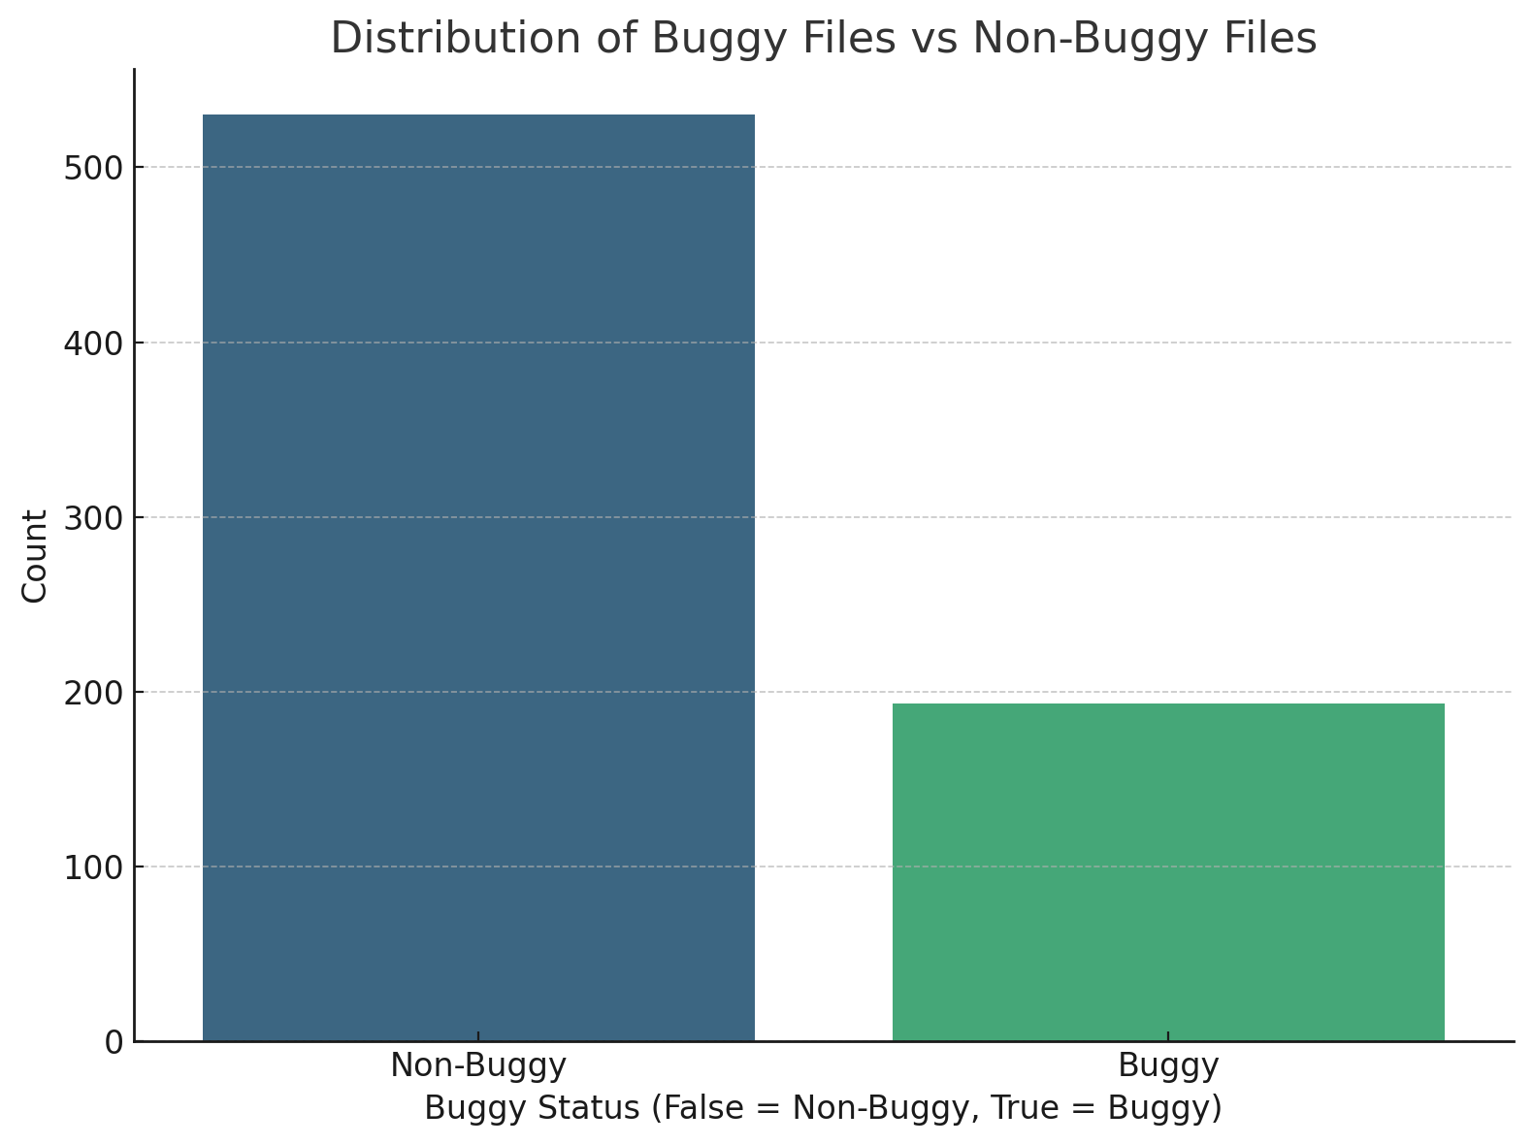
- Which set of features (i.e., all, static only, change only, selected features of your own) achieved the best classification accuracy when used with logistic regression? [10 points]
Selected Features had the best classification accuracy of 91.03% with Logistic Regression.
  - Which features did you select? [5 points]
• RFC • CBO • WMC • SUM_LOC+ • MAX_LOC+ • REF • NO_REV • SUM_CHRN • MAX_SET • Age
  - Why did you select those? Justify your answer and elaborate on why you selected those features. [10 points]
I selected these features because:
- RFE Output: RFE identified them as the most predictive features based on their contribution to the Logistic Regression model.
- Improved Accuracy: Using these features achieved the best accuracy (91.03%) compared to other feature sets.
- From the code, add another algorithm of your choice and repeat step 3 and provide answer to the same question in Step 3. [10 points]
The Change Features Only achieved the best classification accuracy of 94.48% with Random Forest.
While Logistic Regression performed well with selected features, Random Forest was better at handling the non-linearity and interactions between the features.
- Which of all these models was the best? [5 points]
  - What are downsides of choosing this model compared to other models?
Random Forest models are more complex which makes it harder to interpret.
  - Which performance metric did you use to justify your choice? Why did you not choose others? [10 points]
I chose Accuracy and Matthews Correlation Coefficient (MCC). I did so because MCC is a balanced metric that considers true and false positives/negatives. Other metrics like precision and recall are useful but focus on specific aspects of the model's performance.
- How does the choice of the features affect the performance of the classification models? Provide evidence. [10 points]
The features you choose can make a big difference in how well the model performs:
- All Features: Using every feature will include useless features, which can slightly lower performance.
- Static Features Only: These features didn't work very well, which caused lower accuracy.
- Change Features Only: These were the best for Random Forest because they are closely related to finding bugs.
- Selected Features: Picking only the most important features helped Logistic Regression have a higher accuracy.
Evidence:
- Logistic Regression's accuracy went up from 87.59% (All Features) to 91.03% (Selected Features).
- Random Forest did best with 94.48% using only Change Features.

- Submit your code on GitHub [10 points]
Bonus:
Provide 5 line charts that show each of the performance metrics (i.e., Accuracy, Precision, Recall…etc.) for each of the experiments. [10 points]
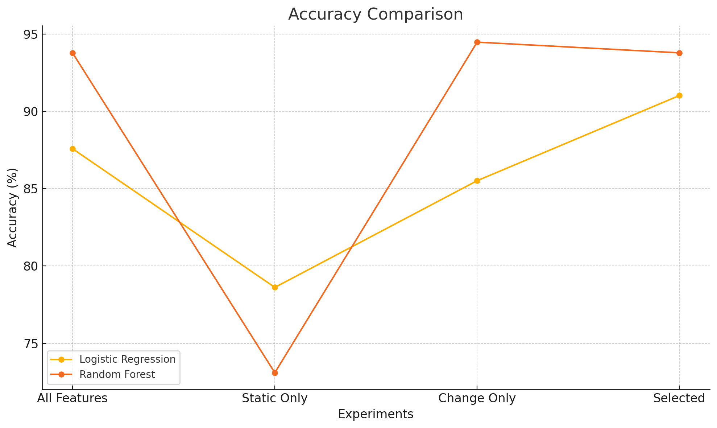
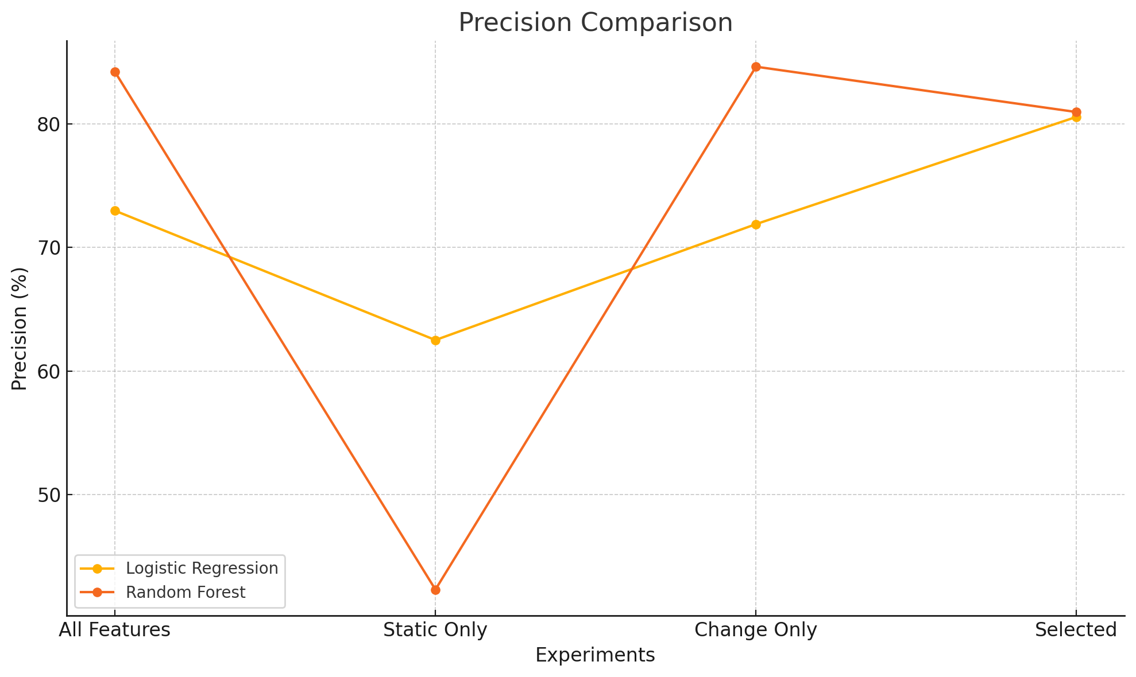
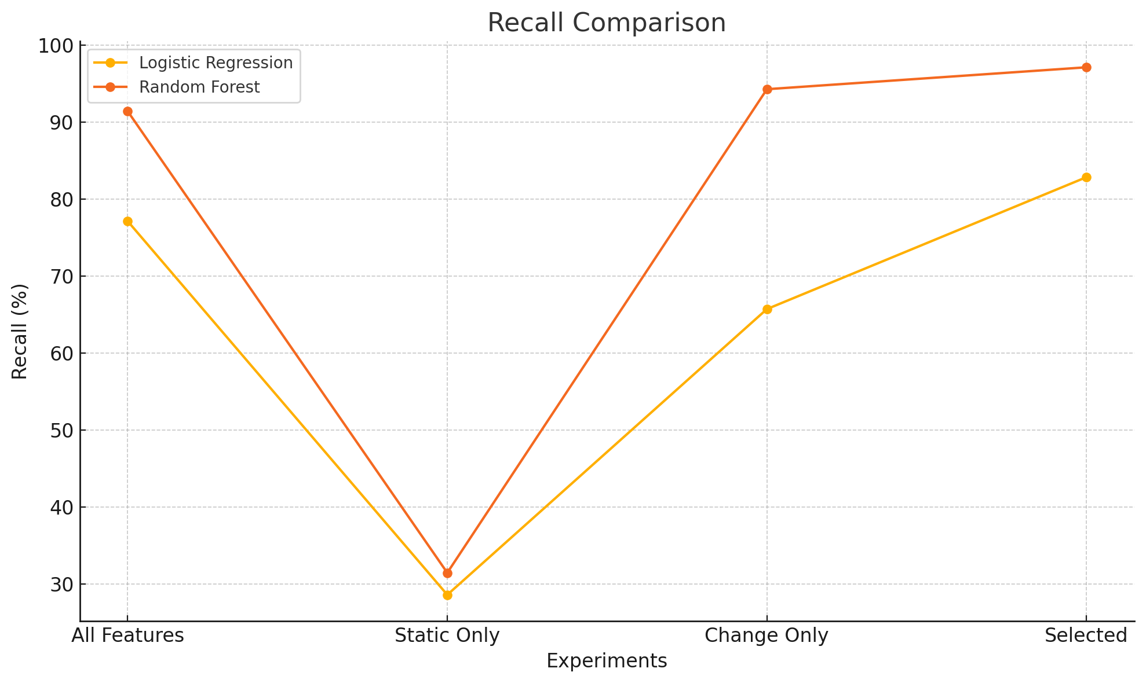
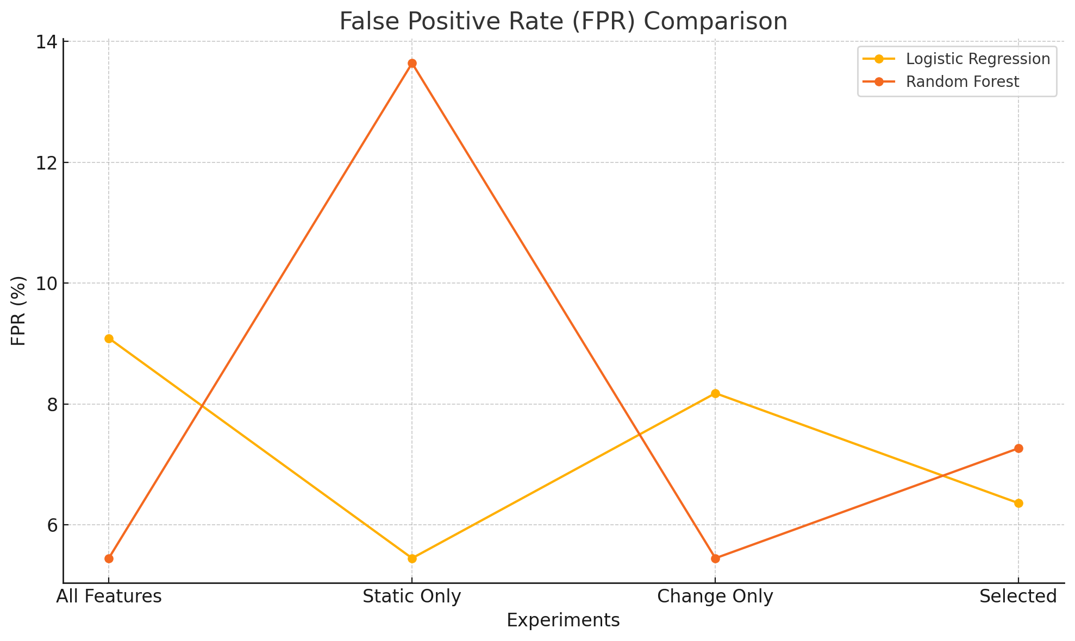
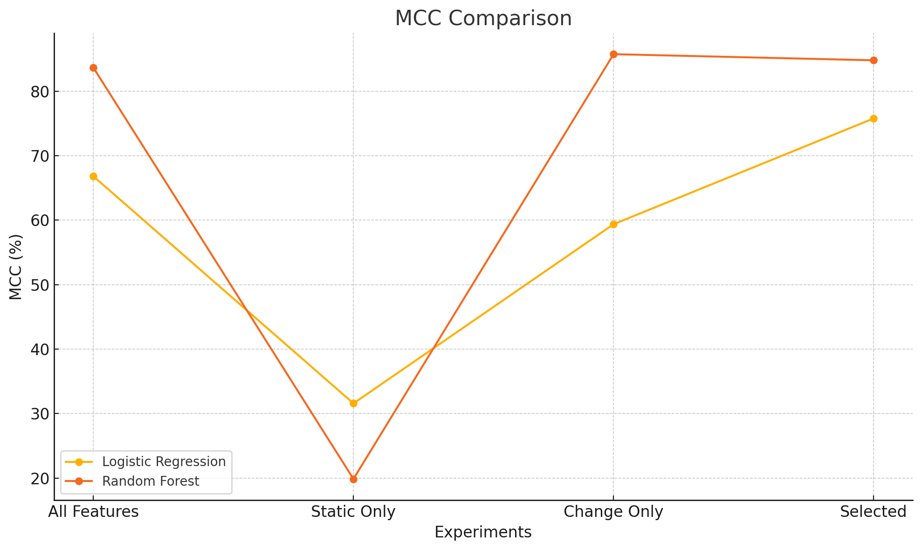

Bibliography
[1] (n.d.). Retrieved from Apache Synapse: https://projects.apache.org/project.html?synapse
[2] Ahmad, Mohammad Jamil, Katerina Goseva-Popstojanova, and Robyn R. Lutz. "The untold impact of learning approaches on software fault-proneness predictions: an analysis of temporal aspects." Empirical Software Engineering 29.4 (2024): 87. (This is also avaialble on the GitHub repor of this class).

